***Collaborative Robotics Modeling***

***FMCS 2018***

* not obliged to TRIO+, we can use plain TRIO.
* we do not need to model the logic. we do not tell it where to go and how. we do not need to model the directions (some complicated models have but it is definitely out of our scope). we are working like a camera from the ceiling and observing what the robot does.
  + one of our safety reactions could be a lower bound on start point, end point separation (?)
* discrete time
* movements can be defined roughly (eg no need for diagonal movement)

we do not need to model movement but we should model stuff like separation.

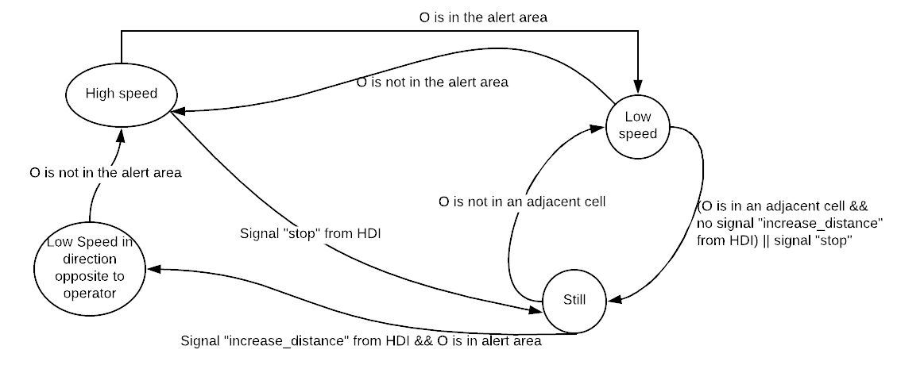

* quando il R si è vicino all’operatore può muoversi solo nelle 2 | 3 direzioni opposte ad esso.
* caso dell’operatore incastrato: risolto parzialmente con la frase sopra + mettiamo un comando sull’HDI per far spostare il robot/ farlo andare da qualche parte in particolare.
* can predicates take variables (domains) as input?
* signals stop e increase_distance : dire che funzionano solo per certi stati definiti

# TRIO BOT

* dobbiamo preoccuparci della tutela degli oggetti che raccoglie? (i.e. muoversi piano quando li raccoglie)
* dobbiamo immaginare i motori come attivi quando l’operatore riloca il braccio?
* il corpo con le ruote puo’ essere modellizzato come unico?

## Classes

### Operator

HEAD AREA

ARMS (AND HANDS)

BODY AND LEGS

->HDI

### Layout(25 x 25 cm tiles)

**Import** Robot, Operator;

**Signature** -

**Visible** -

**Temporal domain** discrete;

**Modules**

Robot

### Robot

**Import** Robot_Arm;

**Signature** -

**Visible** go, motion_state, orientation_state;

**Temporal domain** discrete;

**TD Items**

**domains**

moving: {yes, no}

direction: {up, down, left, right}

speed: {slow, fast}

orientation: {up, down, left, right}

**items**

state motion_state(moving, direction, speed)

state orientation_state()

event go(direction, speed)

### Robot_Arm

when in mobile mode the arm should be retracted

MULTIPLE LINK

END EFFECTOR

state

### Human Device Interface (HDI)

DISPLAY

modalita’ di movimento:

very slow

slow

hign